Kunming HQ
Kunming, the "City of Eternal Spring" with pleasant climate and beautiful scenery,
offers the perfect environment for learning Chinese while experiencing the collision of modern urban life and traditional Chinese culture.

(一个视频，昆明概览）
- One on one personalized course
- Rich supporting facilities
- Excellent tutors with professional certificates and rich teaching experience
- 3 meals Monday to Friday and accommodation
One on one personalized course
Course type available：
one on one intensive course for all language level/goals and culture demand
one on one HSK preparation
one on one Business Chinese
one on one Travel Chinese
We will tailor your course to your personal demand and language level and match you with the tutor who is most suitable for you.

Classes are held from every Monday to Friday. You can choose to study 4 hours, 5 hours or 6 hours per day. The daily class schedule is very flexible and can be adjusted according to your dynamic requirements.

We adopt a learning-practice combination model. Your tutor will not only help you achieve your learning goals, but also create rich real-world contexts for you and accompany you to practice in all-Chinese speaking environment, truly combining learning with application and naturally integrating into the local life.

(教学中的图片+户外课图片)
Abundant supporting facilities

Our main campus located in the core of Kunming city center, offering the most convenient and comprehensive learning and living facilities.

Full campus facilities, modern classrooms, library and study areas, leisure space, cultural activities center are all available.
（一大堆图片）
学习区域

休闲区域

公共区域

……
All the life scenes you need are at your side, you only need to go downstairs to encounter the vivid local life.
（一大堆图片）

咖啡馆

健身房

电影院

Live house

酒吧

商场

餐厅

小吃街和小吃广场

露天集市

超市

银行

……
Of course, it is also very convenient for you to go to other places in the city, the subway station and bus station are both very close to you.
Excellent tutors
All tutors in our team have undergone comprehensive training and hold professional certificates，CTCSOL（Certificates for Teachers of Chinese to Speaker of Other Languages）or Teacher qualification certificate，together with rich teaching experiences.

They will provide you with patient, professional and targeted teaching, and solve your problems with a variety of different methods, making the lessons interesting and practical.
（老师和学生一对一上课图片）
（这里请增加一个按键链接到导师团队）
More info about tutor team
Accommodation
The accommodation for you is right next to the main campus, which is very convenient.

Your room is an independent room with a private bathroom, clean, tidy, safe and comfortable.

Free room cleaning service is offered everyday.

24-hour hot water, air conditioner, WiFi and other necessary living facilities are all included.

(几张房间的图片）

How to get Kunming
Kunming is located in Yunnan Province in southwest China，the most convenient way to reach Kunming is by plane.
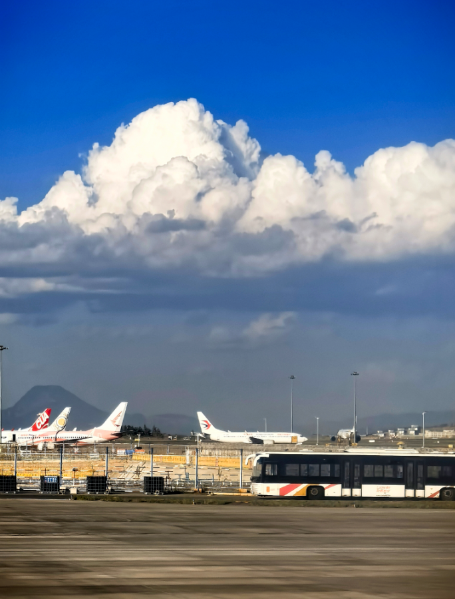
Kunming Changshui International Airport is the core aviation hub of Kunming, the International Airport has 33 international routes, covering 17 countries and regions.

Pricing
Special offer！
4 hours per day (20 hours a week)
$688 / week
5 hours per day (25 hours a week)
$785 / week
6 hours per day (30 hours a week)
$880/ week
Ready to launch your Chinese learning journey?
Apply now

The fee includes:
Personalized Chinese course per week
Program certificate
3 meals Monday to Friday and accommodation
Airport pick-up and drop-off
Orientation
All the campus facilities
Room cleaning everyday
Free coffee everyday（only Kunming HQ）
Free WIFI
After class activities and cultural activities（only Kunming HQ）
Commonly used medicines
24/7 support
Visa support materials

